**Lab 5 Made by Sanzhar Anarbay, KalybaevYersultan**

**Part 1: To create web database for course project**

* 1. To provide short description of your database.

Generally, our database is about movie rental website and this database will store data about movies. This database will store data about movie categories , genres, actors etc. of films.

* 1. Conceptual model of database or Relational model of DB . Your database should contain at least 5 entities. As conceptual model of your DB you can use ER model. Short description for each table or entities
* Category – categories of films
* Inventory – is store of film
* Customer – customer of website (personal information)
* Address – link to address_id attribute of customer table
* City – link to city_id attribute of customer table
* Country – link to country_id attribute of customer table
* Store – store or place of db
* Rental – rent or order of film
* Payment – payment of film
* Staff- person of website which has certain role
* Actor – information about actor
* Film_actor - actor of films in order to search film by actor
* Film – films (main table in db)
* Film_category – category of film
* Language – film language

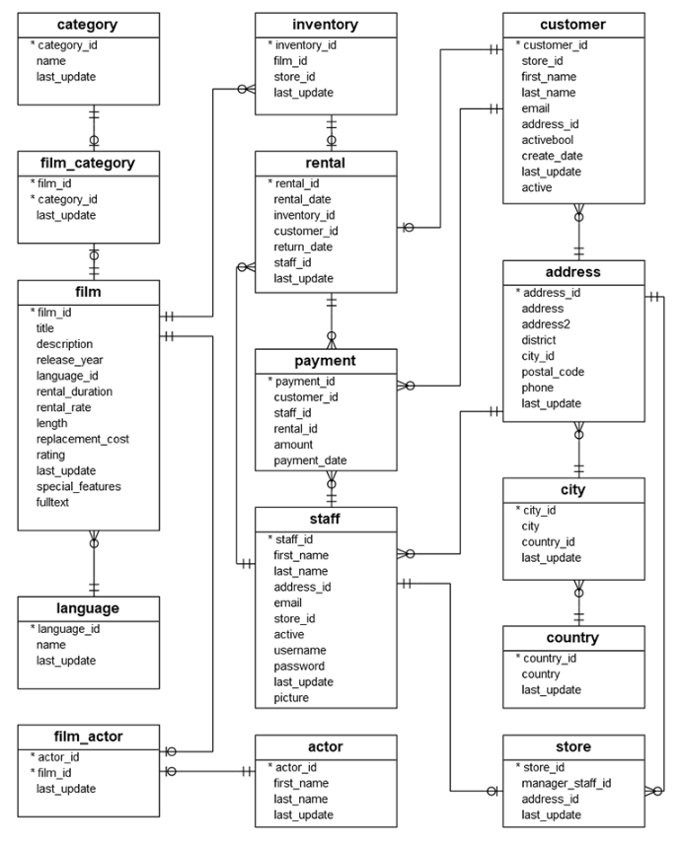

1. Normalizing DB into 1NF, 2FN and 3NF

UNF 1NF

|  |
| --- |
| **Film** |
| Film_info |
| language |
| rent |
| rating |
| features |
| updates |

|  |
| --- |
| **Film** |
| title |
| description |
| Release_year |
| Language_id(PK) |
| Rental_duration |
| Length |
| rating |
| Last_update |
| Special_features |

1NF 2NF

|  |
| --- |
| **Film** |
| Film_id(PK) |
| title |
| description |
| Language_id(FK) |
| Rental_duration |
| length |
| rating |
| Last_update |
| Special_features |

|  |
| --- |
| **Film** |
| title |
| description |
| Release_year |
| Language_id(PK,FK) |
| Rental_duration |
| Length |
| rating |
| Last_update |
| Special_features |

2NF 3NF

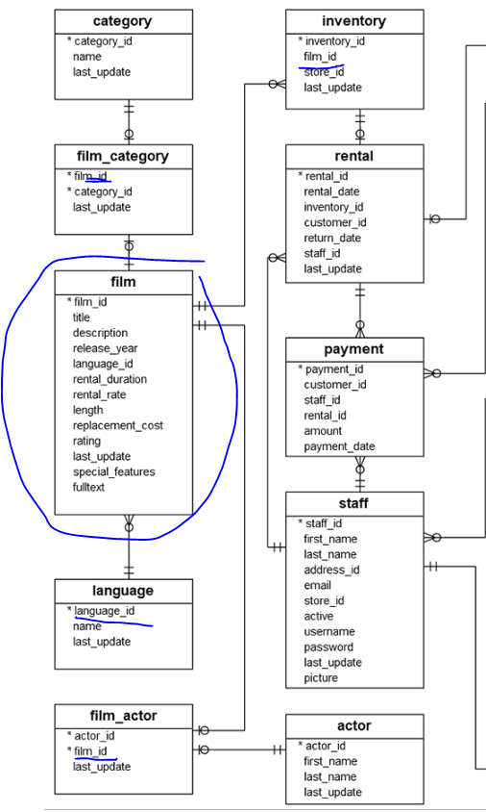

1. Physical database design (process of creation DB).

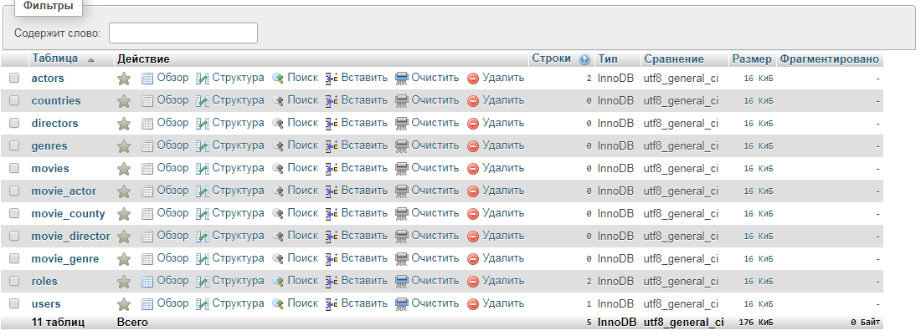

1. You need to include into report all SQL queries of the DB as your report.

